Developer Guide

For

Travel Planner Pro

By Ingrid Seah

20 July 2026

Table of Contents
1. Introduction 3
1.1 Purpose 3
1.2 Project Scope 3
2. Developer Guide 4
2.1 Database 4
2.2 Backend 5
2.3 Frontend 5
2.3.1 Authentication Page 5
2.3.2 Navigation Bar (Navbar) 6
2.3.3 Home Page 6
2.3.4 Trip Page 7
3.3.5 Diary Page 8
3.3.6 Todo Page 8
2.4 Logout 10
Appendix 10

1. Introduction

1.1 Purpose
The intention of this developer guide is to provide future developers with a comprehensive overview of the project deliverables. It serves as a foundational resource for understanding the system architecture, core functionalities, and ongoing maintenance requirements, ensuring a smooth transition and continued scalability of the Travel Planner Pro application.

1.2 Project Scope
The Travel Planner Pro project is a single-level user hierarchy that is focused on allowing users to plan their upcoming trips without the stress that sometimes comes from public viewership. The web application has features such as a location-based activity generator, currency converter, to do list, and personal diary. The main goal is to allow users to freely romanticize their upcoming trips without the stress of itineraries and type-A schedules.

2. Developer Guide

2.1 Database
The project mainly uses SQL Database on Neon Console for user authentication and to store users’ trips, diary entries, todos for trips. The table below explains the functions of each table in Table 1. The relationships of each table is further explained in the ERD diagram in Figure 1.

Table Name | Purpose
travel_users | Stores the user’s email and passwords for user authentication
trips | Stores the name, destination, start date, and end date of the trips
diary_entries | Stores the image urls and caption of diary entries of a trip
todos | Stores the todos of an upcoming/ongoing trip
Table 1: List of Table Names and Purpose
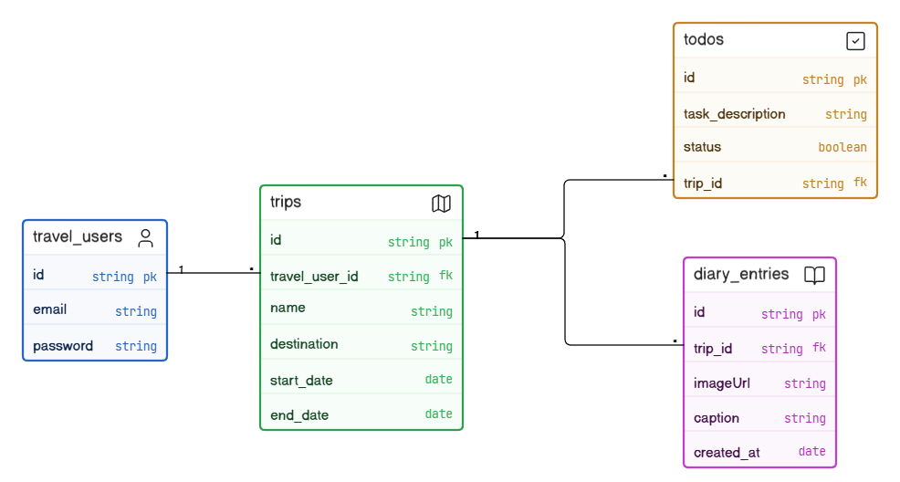
Figure 1: ERD Diagram of SQL Database
The project utilises Google Firebase Storage to store the images uploaded as diary entries by the user. It is stored under the file “diary-entries”.

2.2 Backend
Before starting the project, launch the Travel Planner API on Visual Studio Code by typing “nodemon index” in the terminal. A browser page will appear with a list of definitions for each endpoint. Please note that although this project utilises two different APIs, a currency converter and Photon API, only the latter is found in the backend. Photon API is an open-source API that does not require an API key.

2.3 Frontend

2.3.1 Authentication Page
New users can sign up by entering their email and password. Once that is completed, they will be immediately logged in and redirected to the Home Page. Similarly, a preexisting user has to provide their email and password before being able to log in.
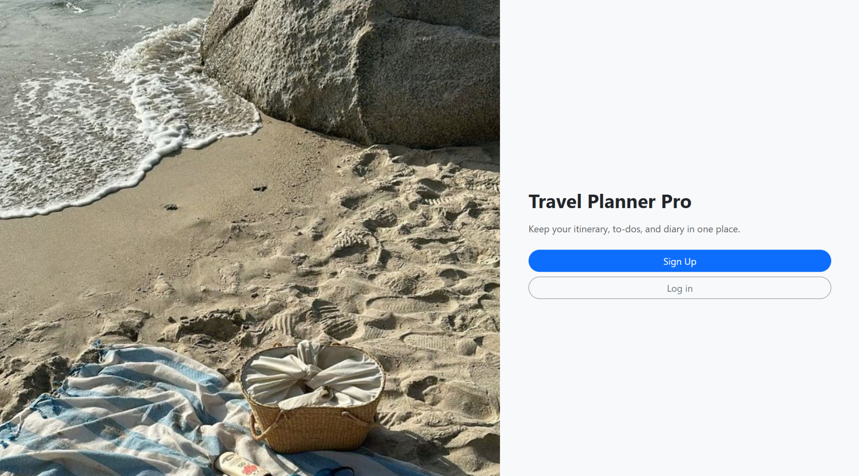
Figure 2: Authentication Page

2.3.2 Navigation Bar (Navbar)
This component (see Figure 3) can be found consistently throughout the project except for the authentication page. It consists of the project name, “Travel Planner”, links to the other pages, and the logout. When clicked on the “Travel Planner”, it will redirect the user to the home page. The links to the other pages will be explained as we go through the report for better understanding.

2.3.3 Home Page
Once a user has signed up or logged in, they will be redirected to the Home page. Here, the user may search up activities for their trip by entering a destination (e.g. San Francisco, Prague) into the search bar and clicking “🔍Search”. The program uses Photon API to fetch the local activities of the given destination. The user may click on the activities to be redirected to another website for further information.
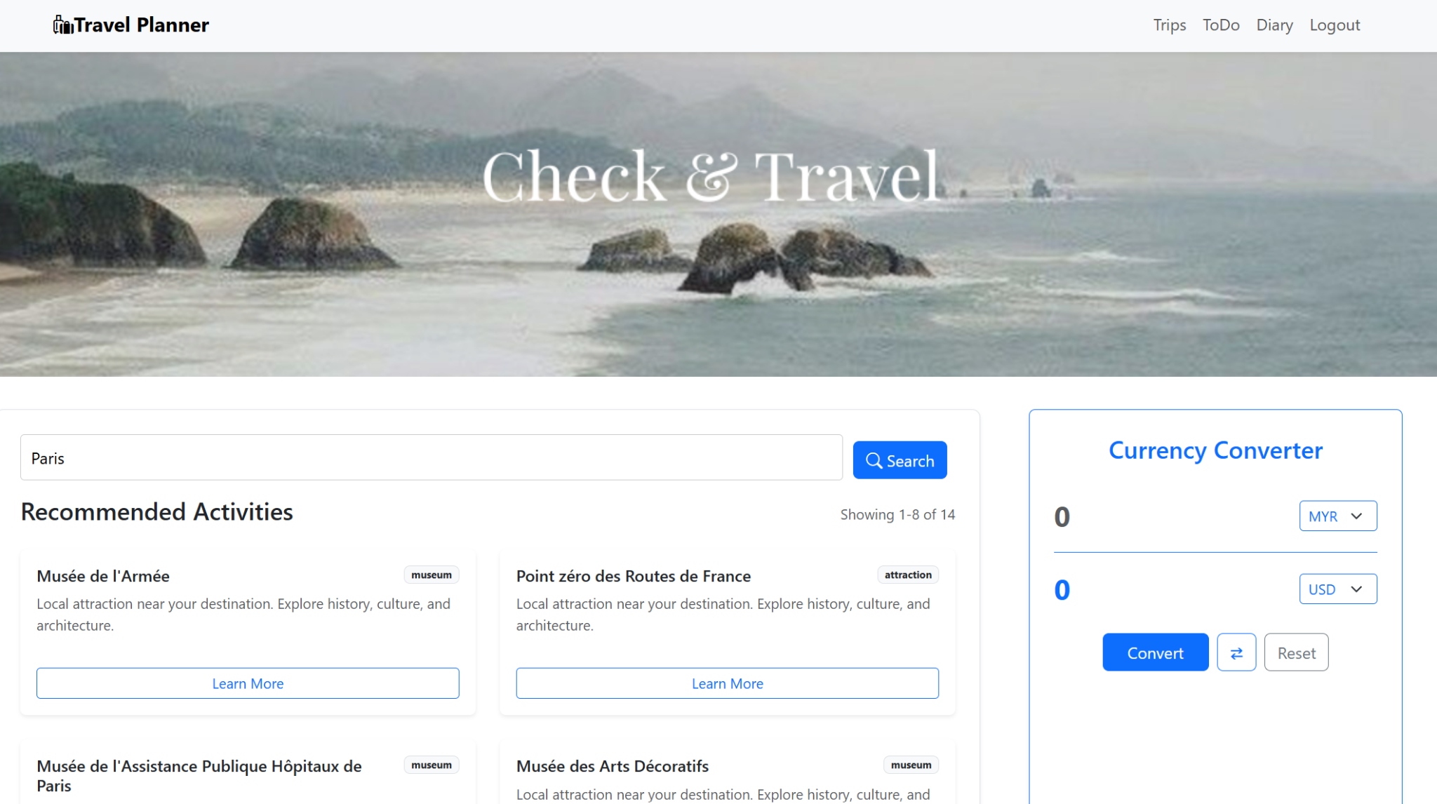
Figure 3: Home Page
On the right of the search bar is a currency converter that allows users to check exchange rates with 10+ currencies. This component also includes a swap and reset button to improve user experience. This page does not allow hotel or flight bookings. It is merely a place to allow users to get a rough idea of what to do on their next holiday. Once a user has decided on a destination, they can maneuver themselves to the navbar and find “Trips”.

2.3.4 Trip Page
Initially, this page is empty and it is up to the users to fill it up! To add a trip, click on the “+” button at the bottom right corner of the page. A modal will appear to prompt the user for a name for the trip, the destination, and the duration. The trip can be an upcoming one or from the past.
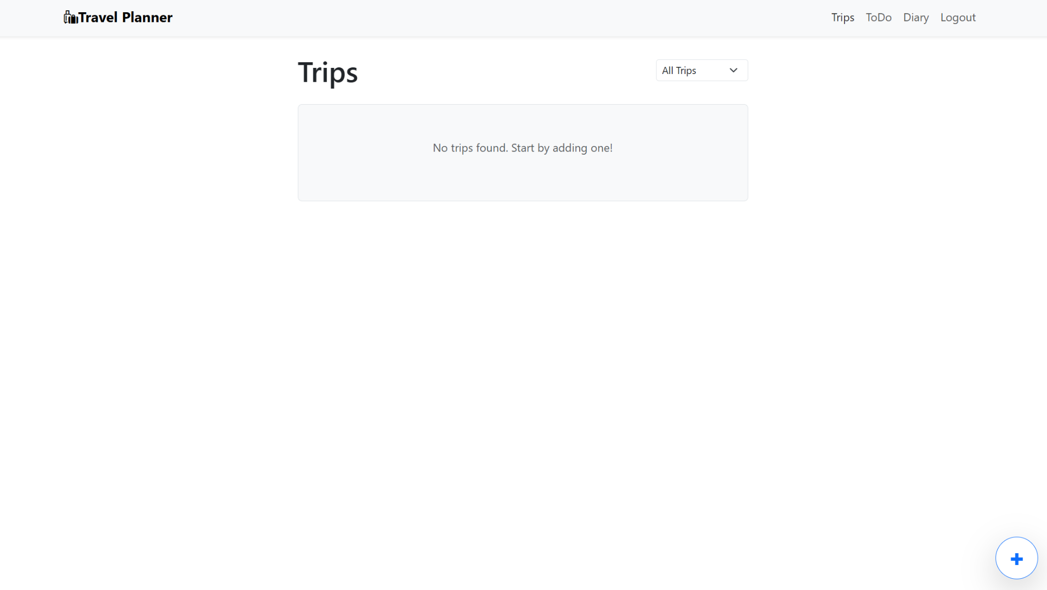
Figure 4: Trip Page
Once submitted, a card with blue outline (see Figure 5) will appear displaying the trip details and an additional countdown feature for the numbers of days left till the trip begins. Should the trip be an old one, the card’s outline will be gray (see Figure 5), and the countdown will display “Trip completed” instead. Each card can be edited or deleted on click. It also includes two buttons, a book and a checklist, for the diary and to-do list respectively. The user can click either one of the buttons to be redirected to the respective pages, Diary Page and Todo Page.
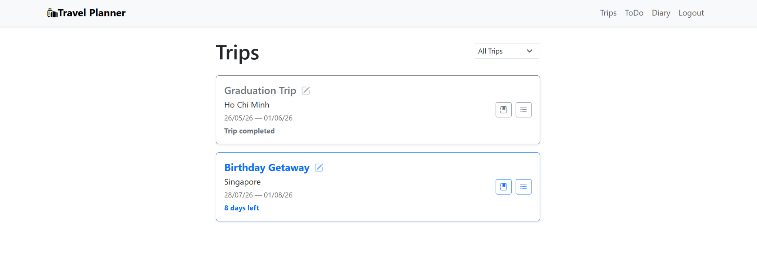
Figure 5: Trip Page with Cards

3.3.5 Diary Page
This page can be accessed from the Navbar, however, users cannot enter a new diary here. This page is the general view of all the diary entries created by the user. Users have to create a trip before being to create a diary entry, hence the “book” button on the trip cards.
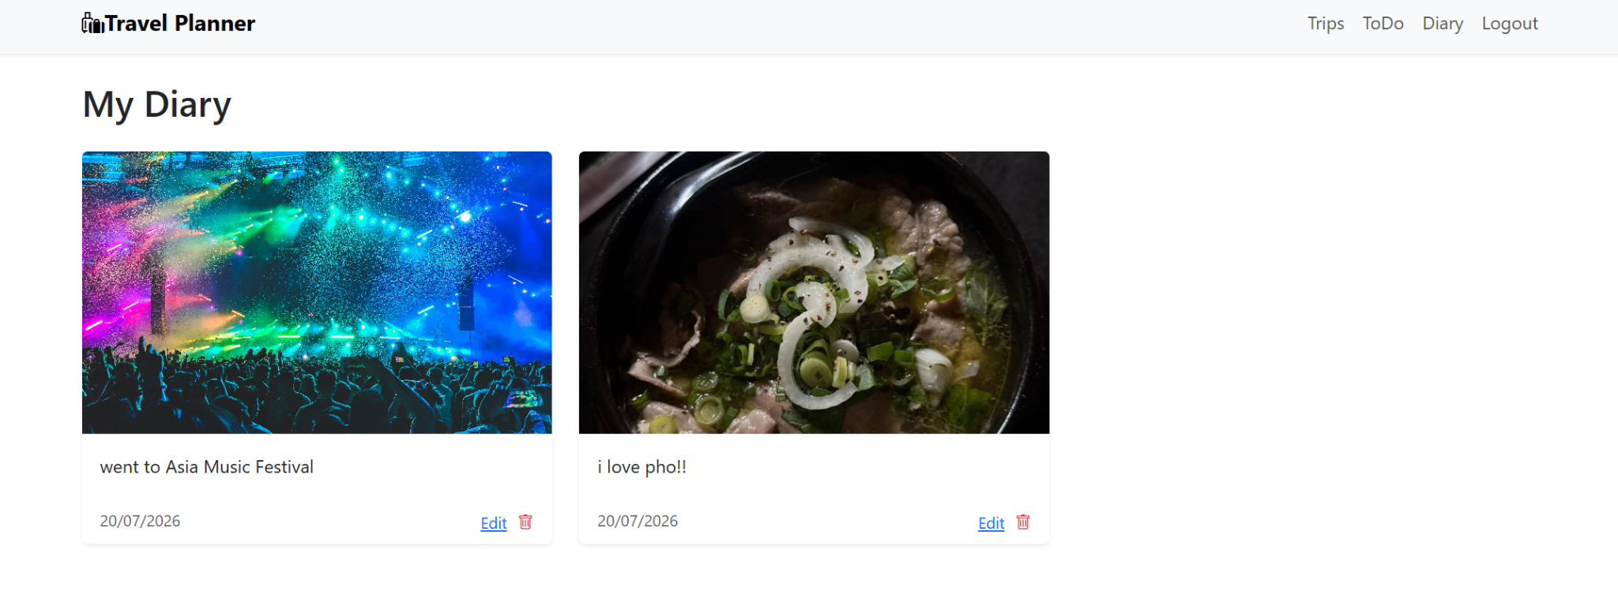
Figure 6: Diary Page with All Entries
Each entry allows the user to add an image and a caption. The image is compulsory, meaning that if an image is not included, the user cannot upload a diary entry. Each diary entry is also saved with the date created to the database. Should the user want to edit or delete an entry, they may do so by clicking either button on each entry card (see Figure 6).

3.3.6 Todo Page
The Todo Page is also accessible by the navbar, but similarly with the Diary Page, users can only enter new todos by clicking on the checklist button in the trip card in the Trip Page. Clicking on “ToDo” in the navbar will display all the todos but will not include an add button to create todos (see Figure 7). A table will list the todos, their status, and an action button to delete. If the user would like to make changes to the todo such as change its name or mark as completed, they may click on the todo. When a todo is marked as completed, the status will turn green.
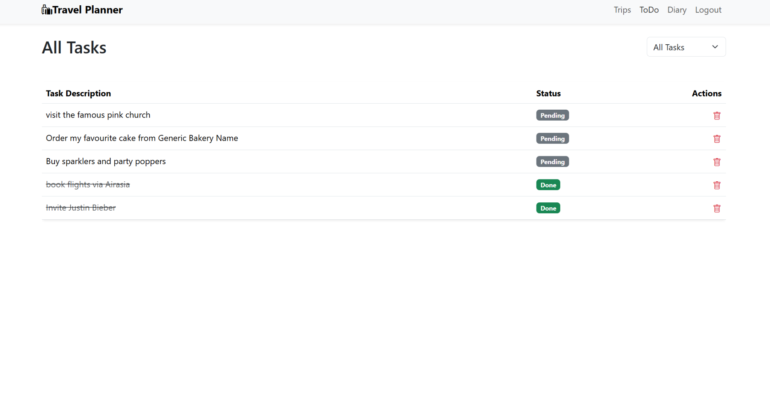
Figure 7: Todo Page with No Add Button
The todos accessed via the navbar displays all the todos from each trip. To specify a trip’s todos, head over to the Trip Page and click on the checklist button. The user will be redirected to a similar Todo page but the table lists only the todos associated with the trip.
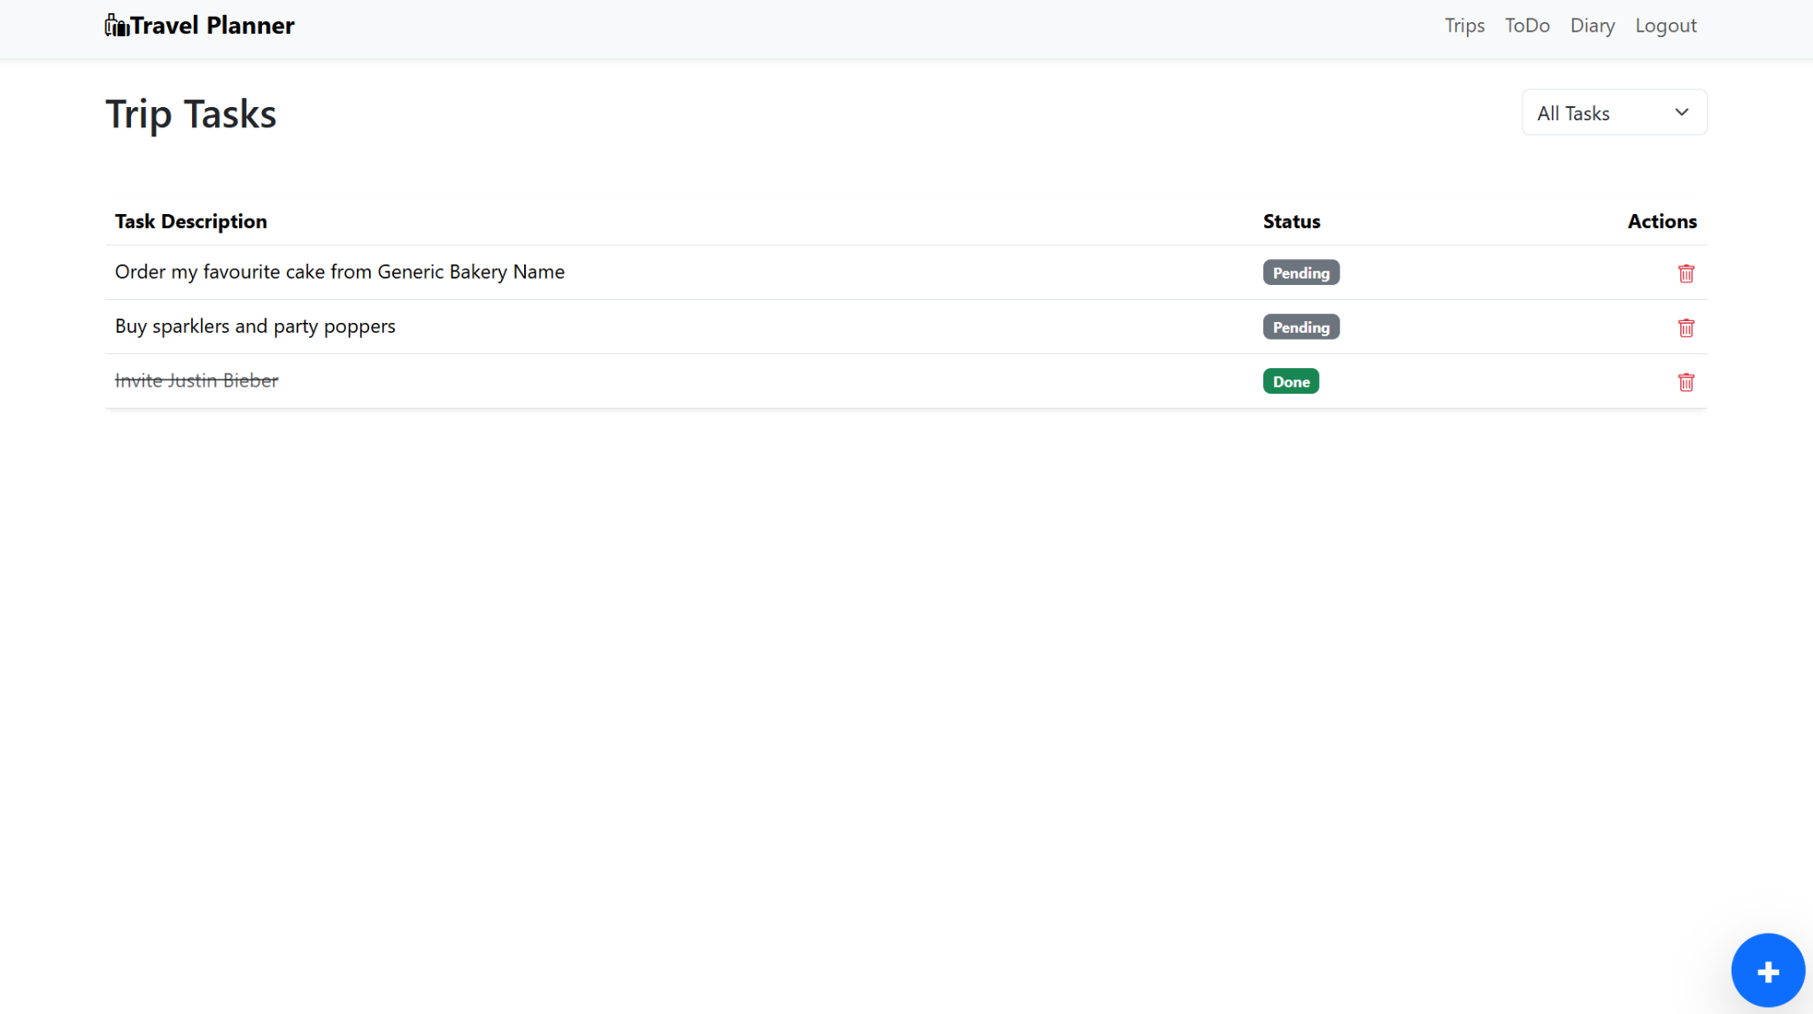
Figure 8: Todo Page Accessed from Trip Card

2.4 Logout
To logout of the Travel Planner Pro, click on “Logout” found in the navbar. The user will immediately be redirected to the Authentication Page.

Appendix
This section includes the links for the project.
- Travel Planner Pro (hosted on Vercel)
- Travel Planner Pro (Github)
- Travel Planner API (hosted on Vercel)
- Travel Planner API (Github)
- Overture Maps API

